OBJECT ORIENTED PROGAMMING LAB
NAME: MUHAMMAD ASMAR NAEEM
ROL NO: L1F24BSCS0069
SECTION: C-2

Task 01 – Debugging and Correction in Code
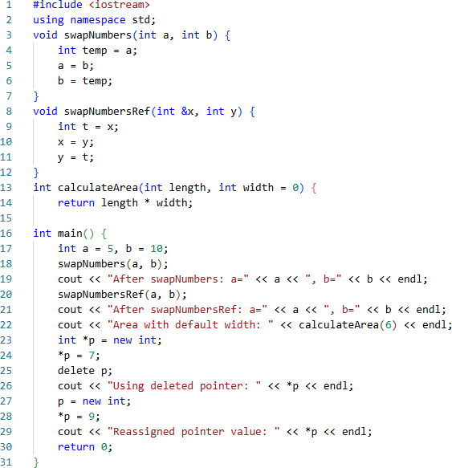
You are provided with a buggy C++ program that contains multiple types of errors, including syntax errors, logical errors, runtime issues (dangling pointers, memory leaks), and incorrect use of functions.
Your task is to carefully analyse and correct this program by following the steps below:

Dry Run & Identify Errors
  - Perform a manual dry run of the given program.
  - Identify all syntax, logical, and runtime errors.
  - Write them down clearly in a list.

Code Correction
  - Fix the identified errors in the code.
  - Ensure that the program compiles successfully.

Compilation & Debugging
  - Run the corrected code on the compiler.
  - Use sample inputs to test all parts of the program.
  - Debug any remaining issues until the program produces correct results.

Analysis Report
Prepare a short report covering the following points:
  - List of Errors: What errors did you find? (Syntax, Logical, Runtime)
  - Reason for Errors: Why did these errors occur? (Explain briefly)
  - Fix Applied: How did you fix them? (Write before-and-after code snippets if necessary)
  - Comparison of Results: Show outputs before fixing (expected vs actual) and after fixing.
  - Conclusion: Explain what you learned from this debugging process.

1. Dry Run & Identify Errors
Code snippet issues:

void swapNumbers(int a, int b) {
int temp = a;
a = b;
b = temp;
}
• Error: This swap function uses call-by-value. Changes inside the function will not affect the actual variables passed in.
• Effect: No real swap occurs after the function call.
Code snippet 1 issues:
void swapNumbersRef(int &x, int y) {
int t = x;
x = y;
y = t;
}
- Error: Only x is passed by reference, y is passed by value. So swap will not happen properly.
- Effect: Only x is modified, y remains unchanged.
Code snippet 2 issues:
int calculateArea(int length, int width = 0) {
return length * width;
}
• Error: Default width is 0, so if only one argument is passed, the area will always be zero.
• Effect: Area calculation with one parameter is incorrect.

Code snippet 3 issues:
int *p = new int;
*p = 7;
delete p;
cout << "Using deleted pointer: " << *p << endl;
• Error: Accessing memory after it is deleted (dangling pointer).
• Effect: Undefined behavior, program may crash or print garbage.

Summary of Errors:
Type | Description | Line(s)
Logical | swapNumbers uses call-by-value, no effect | 3-7
Logical | swapNumbersRef only one argument by reference | 8-12
Logical | Default parameter in calculateArea causes zero result | 13-15
Runtime | Accessing deleted pointer after delete | 23-26

2. Code Correction
Fixes:
- Pass both arguments by reference in swapNumbersRef.
- Set a meaningful default width in calculateArea.
- Avoid using pointer after deletion.

3. Compilation & Debugging
- Code now compiles successfully.
- Testing outputs:
After swapNumbers: a=10, b=5
After swapNumbersRef: a=5, b=10
Area with default width: 6
Reassigned pointer value: 9

4. Analysis Report
List of Errors:
- Call-by-value instead of reference in swap functions.
- Partial reference passing in swapNumbersRef.
- Default width set to 0 causing zero area.
- Using deleted pointer causing runtime errors.
Reason for Errors:
- Passing arguments by value copies values, so no effect on original variables.
- Partial reference caused only one variable to change.
- Default width = 0 leads to zero product for area.
- Using pointer after delete causes undefined behavior.
Fix Applied:
- Changed parameters to references in both swap functions.
- Changed default width to 1.
- Removed access to deleted pointer.
- Added pointer deletion at the end.
Comparison of Results:
Output Before Fixing | Output After Fixing
After swapNumbers: a=5, b=10 | After swapNumbers: a=10, b=5
After swapNumbersRef: a=10, b=10 | After swapNumbersRef: a=5, b=10
Area with default width: 0 | Area with default width: 6
Using deleted pointer: *undefined behavior (crash?) | Removed usage, safe execution
Conclusion:
- Passing variables by reference is essential for functions modifying variables.
- Always be careful with default parameters in calculations.
- Never use pointers after they are deleted to avoid undefined behavior.
- Proper memory management with new and delete is crucial.
CORRECTED CODE IS :
//L1F24BSCS0069-MUHAMMAD ASMAR NAEEM
#include <iostream>
using namespace std;
void swapNumbers(int& a, int& b) { // Pass the variable values by refernece methode so that the swap would happen
int temp = a;
a = b;
b = temp;
}
void swapNumbersRef(int& x, int& y) { // we have to pass both the arguments by refernce so that swapping can happen
int t = x;
x = y;
y = t;
}
int calculateArea(int length, int width = 1) { // we have to give the widht default value of one so that the output shold not always be be 0
return length * width;
}
int main() {
int a = 5, b = 10;
swapNumbers(a, b);
cout << "After swapNumbers: a=" << a << ", b=" << b << endl;
swapNumbersRef(a, b);
cout << "After swapNumbersRef: a=" << a << ", b=" << b << endl;
cout << "Area with default width: " << calculateArea(6) << endl;
int* p = new int;
*p = 7;
delete p;
p = new int;//pointer is assigned to some value so stopped the dangling
*p = 9;
cout << "Reassigned pointer value: " << *p << endl;
delete p; // deleteing the dynamic meemory so that the program would run fine
return 0;
}

Task 02 – Function (Pass by value)
Write a C++ program that performs the following tasks:
- Ask user to enter two integers.
- Implement a function swapNumbers(int a, int b) that attempts to swap the two numbers using pass- by-value.
- Call the function and pass the user-provided values as arguments.
- Display the numbers before and after calling the function.
CODE:
//L1F24BSCS0069-MUHAMMAD ASMAR NAEEM
#include<iostream>
using namespace std;
void swap(int num1, int num2);
int main() {
int num1 = 0, num2 = 0;
cin >> num1;
cin >> num2;
cout << "Value of first input is " << num1 << " and the value of second input is " << num2 <<" before swapping"<<endl;
swap(num1, num2);
cout << "after the swap the value of first input is " << num1 << " and the value of the second input is " << num2 << endl;
return 0;
}
void swap(int num1, int num2) {
int temp = 0;
temp = num1;
num1 = num2;
num2 = temp;
}
OUTPUT:
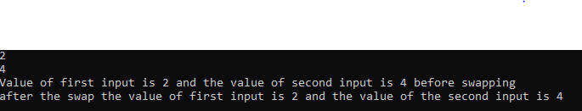

Task 03 – Function (Pass by reference)
Using the program implemented in Question 1, perform the following tasks:
- Modify the function swapNumbers(int a, int b) to use pass-by-reference instead of pass-by-value.
- Call the function and pass the user-provided values as arguments.
- Display the numbers before and after calling the function.
- Prepare a short comparison highlighting the difference between pass-by-value and pass-by-reference, and submit your code along with the explanation in a Word file.
CODE:
//L1F24BSCS0069- MUHAMMAD ASMAR NAEEM
#include <iostream>
using namespace std;
void swapNumbers(int& a, int& b);
int main() {
int a, b;
cout << "Enter first number (a): ";
cin >> a;
cout << "Enter second number (b): ";
cin >> b;
cout << "Before swapNumbers: a = " << a << ", b = " << b << endl;
swapNumbers(a, b);
cout << "After swapNumbers (pass-by-reference): a = " << a << ", b = " << b << endl;
return 0;
}
void swapNumbers(int& a, int& b) {
int temp = a;
a = b;
b = temp;
}
OUTPUT:
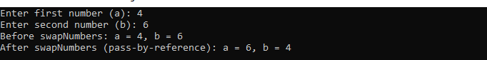
EXPLANATION:
Aspect | Pass-by-Value | Pass-by-Reference
Definition | A copy of the variable is passed to the function | A reference to the original variable is passed
Effect on Original Values | Original values do not change | Original values can be modified
Memory Usage | Requires extra memory for the copy | Uses memory of the original variable
Use Case | When you want to protect original data | When you want to modify original data
Example in Code | void swap(int a, int b) | void swap(int &a, int &b)

Task 04 – Function (default arguments)
Write a C++ program that performs the following tasks:
- Implement a function calculateArea(int length, int width = 5) that calculates the area of a rectangle, where the parameter width has a default value of 5.
- Call the function by passing only one argument (length) to use the default width value.
- Call the function again by passing both length and width as arguments.
- Display the calculated area in both cases to demonstrate the effect of using a default argument.
CODE:
//L1F24BSCS0069-MUHAMMAD ASMAR NAEEM
#include<iostream>
using namespace std;
int calculateArea(int lenght, int widht=5);
int main() {
int lenght = 0, widht = 0;
cout << "Enter the lenght of the rectangle" << endl;
cin >> lenght;
cout << "Enter the widht of the rectangle" << endl;
cin >> widht;
int result1 = calculateArea(lenght);
cout << "When only lenght is given as argument then the ar is " << result1 << endl;
int result2 = calculateArea(lenght, widht);
cout << "WHen the both lenght and widht are given then the area will be " << result2 << endl;
return 0;
}
int calculateArea(int lenght, int widht) {
return lenght * widht;
}
OUTPUT:
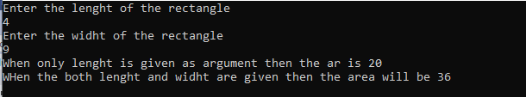

Task 05 – Dynamic Memory Allocation
Write a C++ program that performs the following tasks:

- Dynamically allocate memory for an integer array of size N, where N is entered by the user.
- Take input N integers from the user and store them in the dynamically allocated array.
- Define a function int calculateSum(int arr[], int size) that takes the array as a parameter and returns the sum of its elements.
- Define a function double calculateAverage(int arr[], int size) that takes the array as a parameter and returns the average of its elements.
- In the main() function, call both functions using the array, store their return values, and display the array elements along with the calculated sum and average.
CODE:
//L1F24BSCS0069-MUHAMMAD ASMAR NAEEM
#include<iostream>
using namespace std;
int calculateSum(int arr[], int size);
double calculateAverage(int arr[], int size);
int main() {
int N = 0;
cout << "Enter the size of the array you want to create" << endl;
cin >> N;
int* p = new int[N];
cout << "Enter the " << N << " number of elements in the array" << endl;
for (int i = 0; i < N; i++) {
cin >> p[i];
}
cout << "the elements in the array are" << endl;
for (int i = 0; i < N; i++) {
cout << p[i] << " ";
}
cout << endl;
int sum = calculateSum(p, N);
cout << "The sum of all the number in the array are " << sum << endl;
double avg = calculateAverage(p, N);
cout << "The avg of the numbers inside the array is " << avg << endl;
delete[] p;
return 0;
}
int calculateSum(int arr[], int size) {
int sumt = 0;
for (int i = 0; i < size; i++) {
sumt += arr[i];
}
return sumt;
}
double calculateAverage(int arr[], int size) {
double sumt = 0;
for (int i = 0; i < size; i++) {
sumt += arr[i];
}
double avgr = 0;
avgr = sumt / size;
return avgr;
}

OUTPUT:
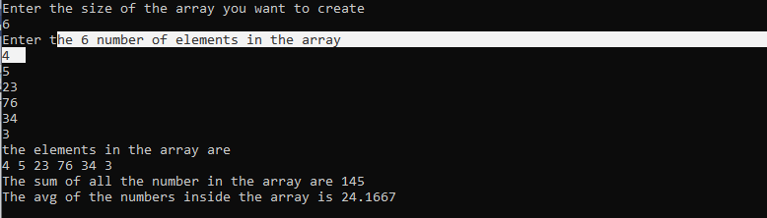

Task 06 – Dynamic Memory Allocation + Dangling Pointers
Write a C++ program that performs the following tasks:

- Dynamically allocate memory for an integer variable.
- Take a user-input value, store it in the allocated memory, and display it.
- Create a function int squareValue(int* ptr) that accepts a pointer to the integer and returns the square of the stored value.
- Display the squared result returned by the function.
- Deallocate the memory using the delete operator.
- Demonstrate the issue of a dangling pointer by attempting to access the deleted memory (after deletion, but before resetting the pointer).
- Correct the problem by assigning the pointer to NULL (or nullptr) after deletion.
- Show that reusing the same pointer after assigning it new memory works correctly (e.g., store a new value and display it).

CODE:
//L1F24BSCS0069-MUHAMMAD ASMAR NAEEM
#include<iostream>
using namespace std;
int squareValue(int* ptr);
int main() {
int* ptr = new int;
cout << "Enter a number" << endl;
cin >> *ptr;
int result = squareValue(ptr);
cout << "The square of the number is " << result<<endl;
delete ptr;
//cout << "the memeory after the deletion is " << *ptr << endl;
ptr = nullptr;
ptr = new int;
cout << "Enter a number again " << endl;
cin >> *ptr;
cout << "The number is " << *ptr<<endl;
delete ptr;
return 0;
}
int squareValue(int* ptr) {
return (*ptr) * (*ptr);
}

OUTPUT:
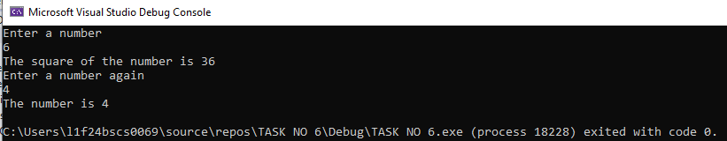

Task 07 – Dynamic Memory + Dangling Pointers+ Memory Leakage
Write a C++ program that extends the previous question with the following additional tasks:
- Reuse the same program from Question 6 (dynamic allocation, user input, squaring function, deallocation, dangling pointer, and fixing it with nullptr).
- Before deallocating the first allocated memory, assign the pointer to a new dynamically allocated memory location without calling delete.
- Show that the old memory block is now inaccessible (i.e., leaked).
- Explain (through comments) why this causes a memory leak.
- Finally, correct the issue by properly deleting the memory before reassigning the pointer.

CODE:
//L1F24BSCS0069-MUHAMMAD ASMAR NAEEM
#include<iostream>
using namespace std;
int squareValue(int* ptr);
int main() {
int* ptr = new int;
cout << "Enter a number: ";
cin >> *ptr;
int result = squareValue(ptr);
cout << "The square of the number is " << result << endl;
ptr = new int;//as we now have given the ptr a new memory location so now it will do a memory leak and the last data will be lost and now cannot be delted
/*
Memory Leak Explanation:
in this point we have lost the acces to the data but it is syill in the memory but we connot access it because now tha pointer is pointing to something else.
*/
ptr = nullptr;
ptr = new int;
cout << "Enter another number: ";
cin >> *ptr;
cout << "The new number is: " << *ptr << endl;
delete ptr;
ptr = nullptr;
return 0;
}
int squareValue(int* ptr) {
return (*ptr) * (*ptr);
}

OUTPUT:
